Unit 7: Factoring
Lesson 2: Factoring a trinomial with a leading coefficient =1
Objectives:
- I can factor a trinomial with a leading coefficient =1
- I understand the connection between the sum and product of the numbers in the factors and the quadratic trinomial.
- I can factor a trinomial with a leading coefficient =1 to solve real-life applications.
Agenda:
- Video 7-2
- Practice
- Application
- Quick Check

Focus Questions:
- How can you factor a quadratic with a leading coefficient of 1 using guess and check?
- What is the connection between the sum and product of the numbers in the factors and the quadratic trinomial?

Vocabulary: Trinomial, Factors
Homework: HW 7-2
Web support:
- https://www.khanacademy.org/math/algebra/polynomial-factorization/factoring-quadratics-1/v/factoring-polynomials-1
- https://www.youtube.com/watch?v=NwrmX6c_JhQ

Study for the midterm there are no do overs

Do Now: Looking back
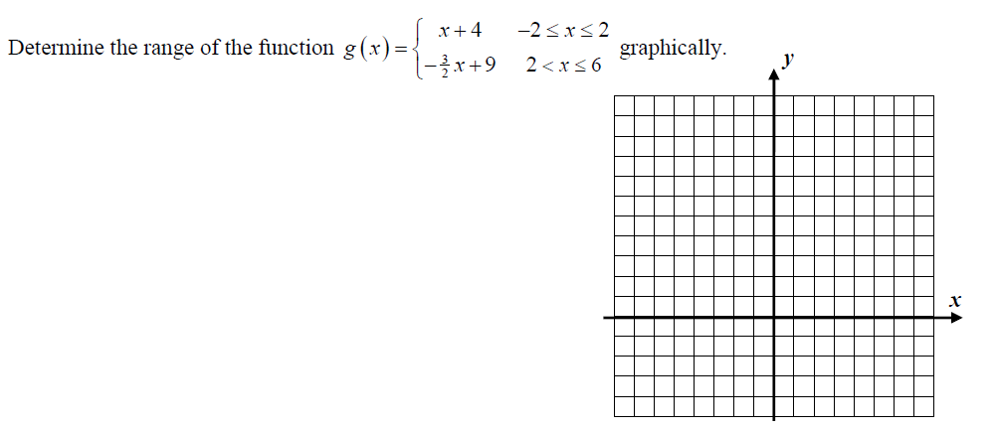

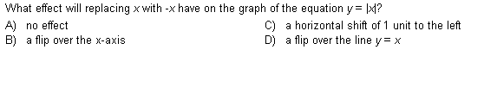
- Use the distributive property and leave your answers in standard form.
- ${\left(1+5x\right)}^{2}$ 2. $(x-3)(3x+3)$

Factor using the two types you learned about from last class.
- $6x^{2}+15x$ 2. $6x^{2}+10x$ 3. $4x^{2}-25$

4. $10x^{3}-35x^{2}$ 5. $81x^{2}-49$ 6. $3x-24$

7. $10x^{2}-15x$ 8. $6x^{3}-8x^{2}+2x$ 9. $4x^{2}+8x+24$

Notes:

To factor a trinomial in the form x2 + bx + c, find two integers whose product is c and whose sum is b. ... For example, to factor x2 + 7x +10, you are looking for two numbers whose sum is 7 (the coefficient of the middle term) and whose product is 10 (the last term).

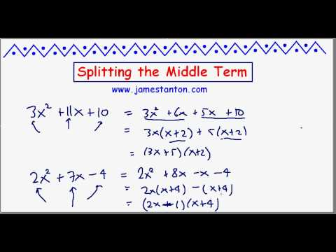
Notes: 7-2: Trinomials Play the video first: AC Method or split the middle.
Factor Trinomials with standard form of ____________________
- $x^{2}+8x+15$ | - $x^{2}-5x+6$
- $x^{2}-2x-8$ | - $x^{2}+7x-18$
- $x^{2}+10x+16$ | - $x^{2}+12x+35$
Your Turn:
- $x^{2}-5x-36$ | - $x^{2}-x-6$
Factor Completely: Sometime you might have to factor twice.
- $3y^{4}-12y^{2}$ | 2. ${2x}^{2}+2x-12$
Name: _________ Date: ____________
Homework 7-2: Factoring Day 2.

- Which of the following products is equivalent to the trinomial $x^{2}-5x-24$ ?
- $(x-12)(x+2)$ (3) $(x-8)(x+3)$

- $(x+12)(x-2)$ (4) $(x+8)(x-3)$

Factoring Using AC Method (Split the middle)

2. $x^{2}-8x+12$ | 3. $x^{2}+2x-8$
- ${ x}^{2}+ 2x – 24$ | - $x^{2}+3x-10$

Mixed problems: Please refer to the Do now or last lesson.
$5. 169y^{4}-100$ 6. $-9x^{4}y^{2}+3x^{2}y^{3}$ 7. ${25x}^{4}-9$

The following might require you to factor twice: Check using the graphing calculator.
8. ${5x}^{3}-5x$ | 9. $x^{3}-12x^{2}+20x$
10 $. 9x^{2}-16$ | ${11 . 2x}^{2}-18$
${12. 12x}^{2}-3$ | $13) x^{4}-81$
14 Word Problems: The length of a rectangle is represented by$(x+3)$ and the width is represented by $(x+1)$.
Express the area of the rectangle as a binomial in terms of x.

